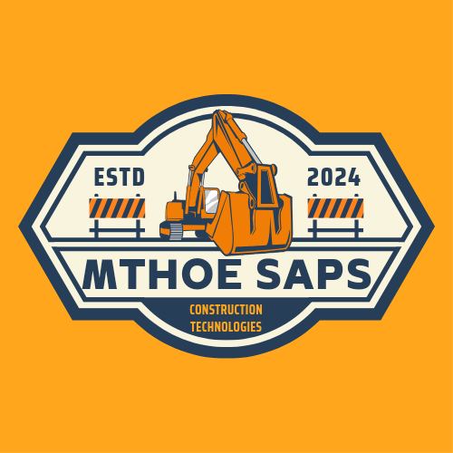

**Mthoe Saps Construction Technologie Bulawayo Mapping Survey Engine Beta Programme Expedition 1 Documentation**

**This documentation includes a tutorial usage of the Mthoe Saps Construction Technologies Bulawayo Mapping Engine for the first mapping expedition between the affiliated parties an Mthoe Saps Construction Technologies.**

NB: All images used in this documentation are obtained from the Bulawayo Mapping Survey Engine (the engine is also capable of producing downloadable maps).

**1. Introduction**

The Bulawayo Mapping Survey Engine is an innovative project aimed at creating a comprehensive mapping system for the city of Bulawayo. This beta programme documentation outlines the objectives, requirements, and timeline for the initial project to commence which involves mapping using a choropleth map to create land zonations in Bulawayo, this is only the first of many mapping expeditions to be done under the beta project.

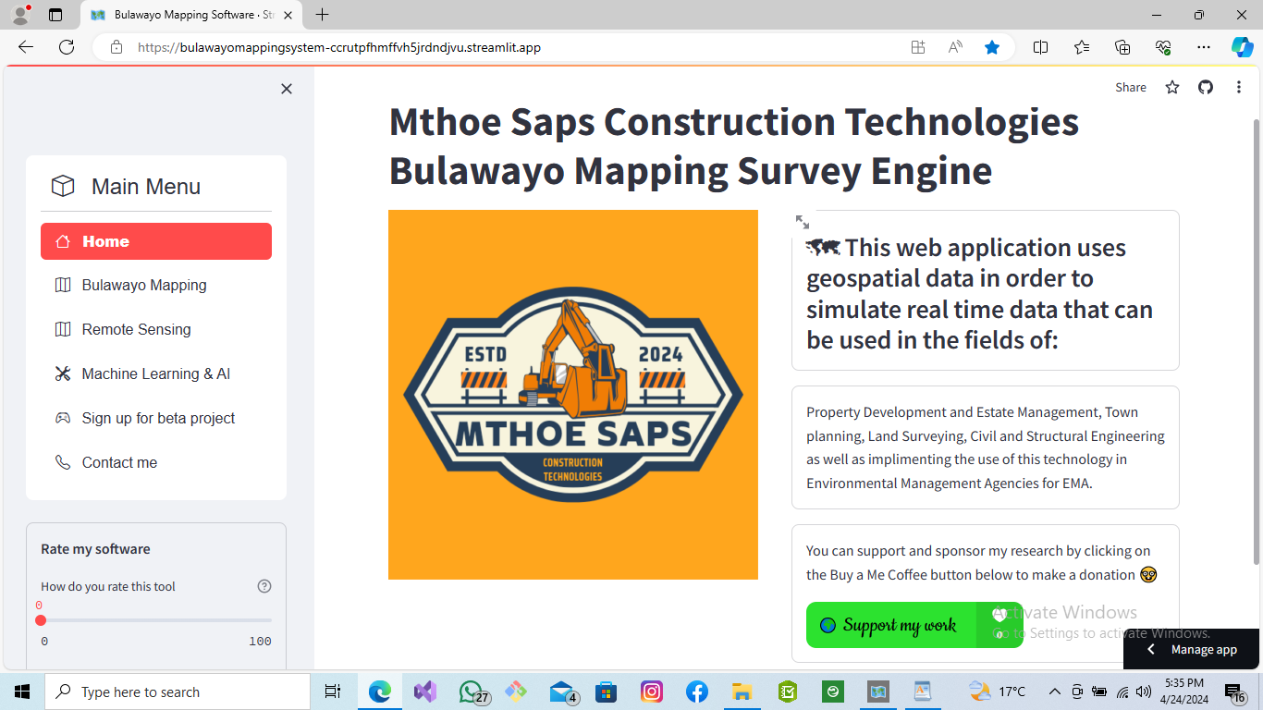

*fig 1 shows the main page of the Mthoe Saps Construction Technologies Bulawayo Mapping Survey Engine. The engines sidebar initial state is usually expanded so you can access it and close it using the top left corner of the webpage (indicated by an x to close and a > to open it).*

**2. Objectives**

The main objectives of the beta programme Phase 1 Documentation are as follows:

- To develop a detailed choropleth map of Bulawayo.

- To create land zonations based on the collected data.

- To evaluate the feasibility and effectiveness of the Bulawayo Mapping Survey Engine.

- To gather feedback from affiliated companies for further improvements.

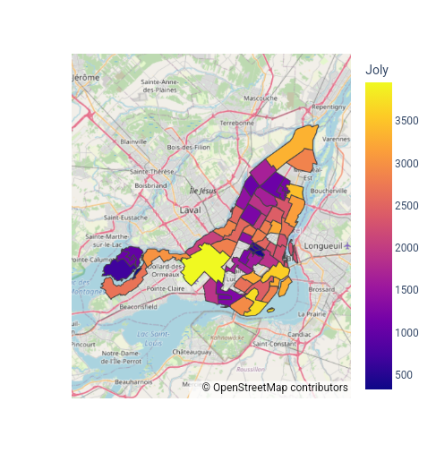

*fig 2 above was reconstructed using the Mapping Survey Engines GIS and Remote Sensing capabilities in order to plot a realtime chloropleth map for the USA comparing voters registration region by region. The goal of this task is to replicate a similar scheme in order to produce a choropleth mapping software for the Bulawayo based affiliated companies that will have custom information displayed for their own use. The data to be displayed will be selected by the affiliated companies as each affiliated company is to have their own mapping and survey software that renders information based on their research.*

**3. Requirements**

In order to participate in the beta programme phase 1 mapping expedition, affiliated companies are required to complete a database form. The form will be in excel format (xlsx) provide essential information for the project, including columns:

- Suburb name

- Global Positioning System coordinates for each location, property and suburb

- Address

- About the specific area

- Population and gdpPerCap for the area

- Land area covered by the company

- Land use type (residential, commercial, industrial, etc.)

All the data is to be filled in by the affiliated members so as to generate their own mapping engines that have their own database based information.

*Fig 3 below shows the Bulawayo Mapping Survey Engine rendering data from a custom database that the research programme* has already configured as the project now has *located 128 High density, medium density and low density suburbs of Bulawayo (we are currently adding more locations to our database, the goal is to hit atleast 1000 accurately located places in Bulawayo by the end of July and have atleast 90% of Bulawayo Mapped out anddocumentaed by the end of the beta project.*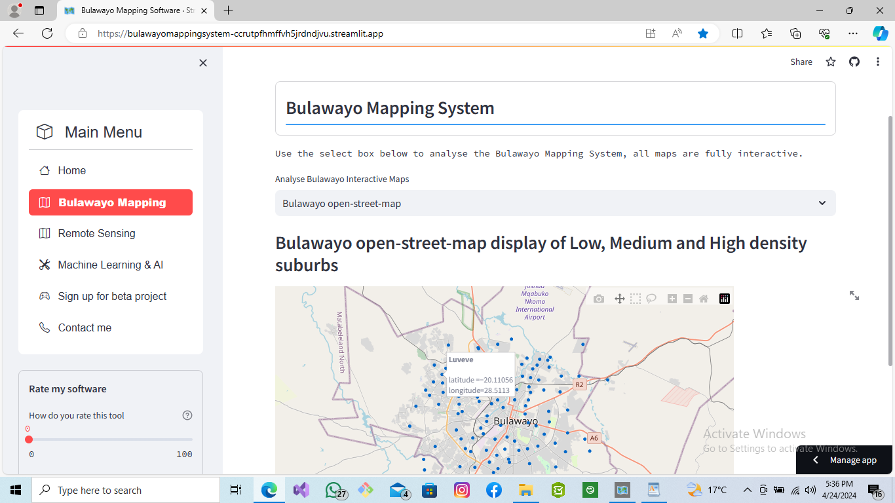

**4. Timeline Indicators**

The following timeline indicators will guide the progression of the beta programme:

The Project is to kick off 13 May 2024 and End 06 August 2024 the mapping software should have 3 added interactive mapping functions such as:

1. A choropleth mapping function of Bulawayo with multi informative features

2. Land Zonation and Warding Map of Bulawayo

3. Master layout of the Bulawayo Map

4. Demographic based Bulawayo mapping system

The timeline breakdown of the activities would be as follows:

**\*\*Phase 1: Data Collection\*\***

- Week 1: Distribute database forms to affiliated companies.

- Week 2-3: Collect completed database forms from affiliated companies.

- Week 4: Compile and validate the collected data.

**\*\*Phase 2: Mapping and Zonation\*\***

- Week 5-6: Analyze the collected data and generate a choropleth map.

- Week 7-8: Define land zonations based on the mapped data.

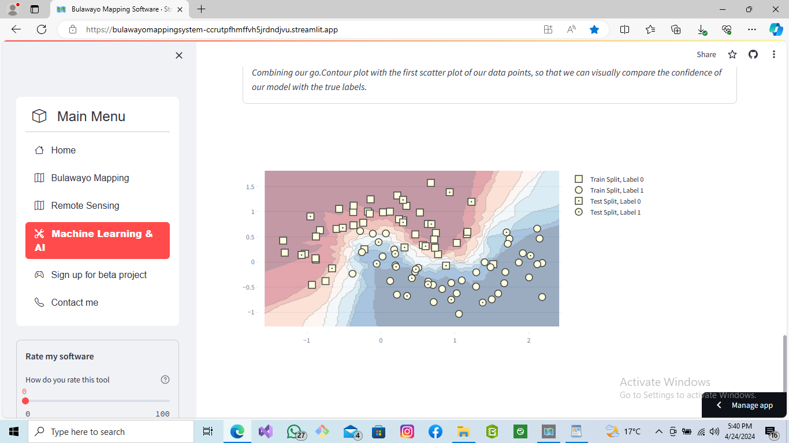

*Fig 4 above display the machine learning and artificial intelligence data merging structure that will be used to model the map and add the data inside the map to make it accurate.*

**\*\*Phase 3: Evaluation and Feedback\*\***

- Week 9-10: Evaluate the feasibility and effectiveness of the Bulawayo Mapping Survey Engine.

- Week 11: Gather feedback from affiliated companies on their experience with the beta programme.

**5. Conclusion**

The Bulawayo Mapping Survey Engine beta programme aims to create a detailed mapping system for Bulawayo by utilizing a choropleth map and establishing land zonations. Affiliated companies are required to complete a database form to provide necessary information for the project. The timeline indicators will guide the progression of the programme, and feedback from the participants will help in further improving the system.

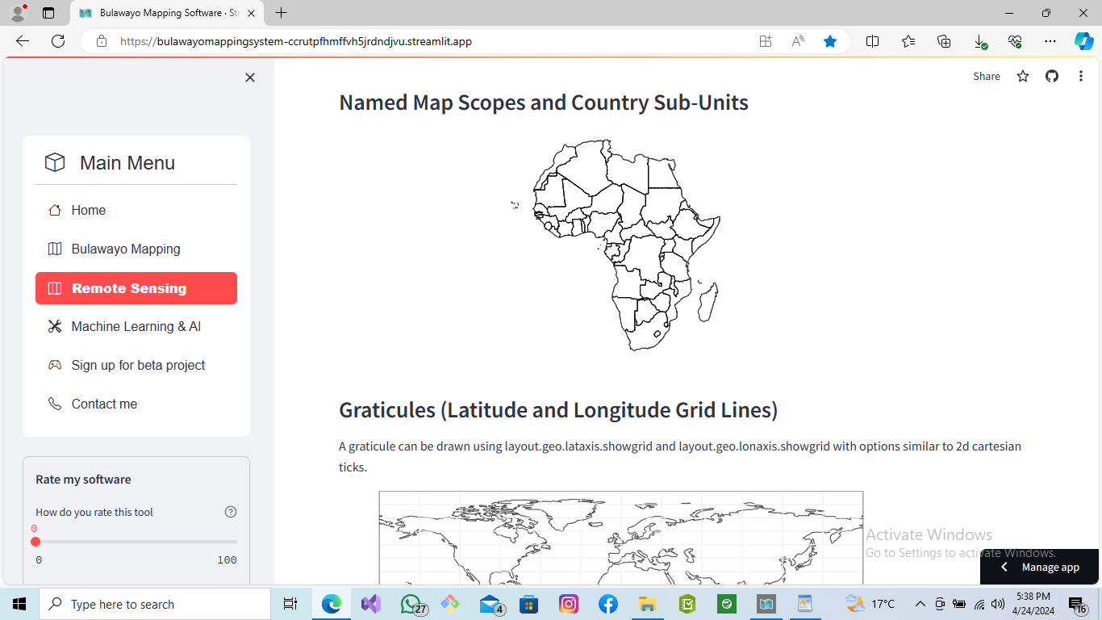*Fig 5 and fig 6 shows the remote sensing abilities that the Mapping and Survey Engine have been equipped with.*

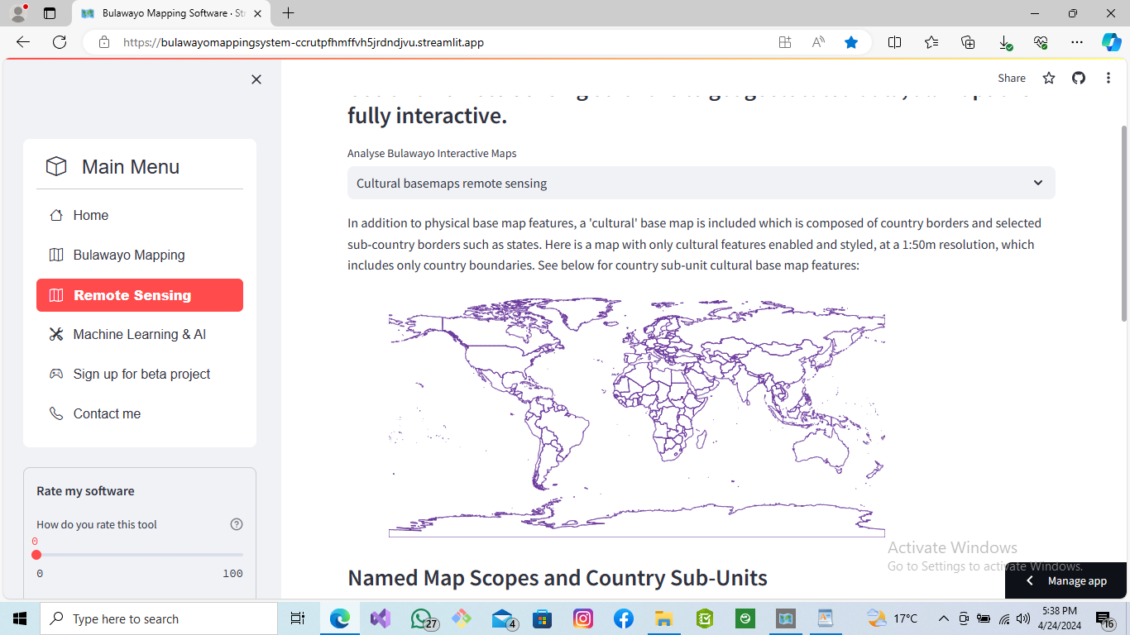

***Sign up for the beta project now and experience a new revolutionary way of GeoMapping and Surveying in Bulawayo. Dont miss out!!***